How to create a navbar in React with Routing
https://www.youtube.com/watch?v=SLfhMt5OUPI

Using window.location.pathname and switch

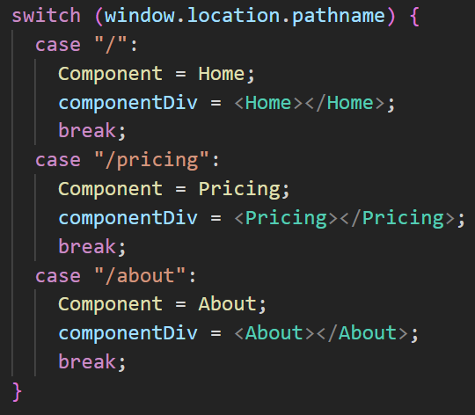
This can become cumbersome with a large number of routes.

Using react-router-com

Install react-router-dom
> npm i react-router-dom

In index.js, import BrowserRouter and wrap <App> in a <BrowserRouter> div.

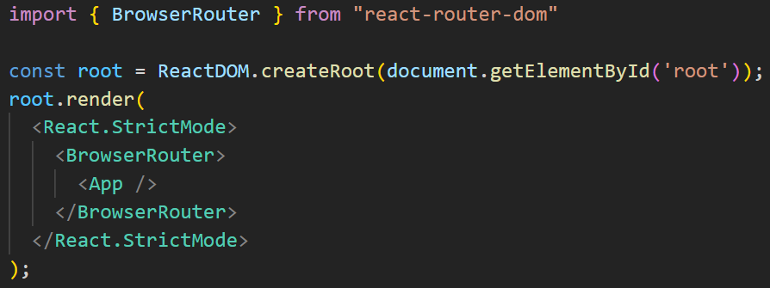
In App.js, import Route and Routes and define the routes – replace the switch statement.

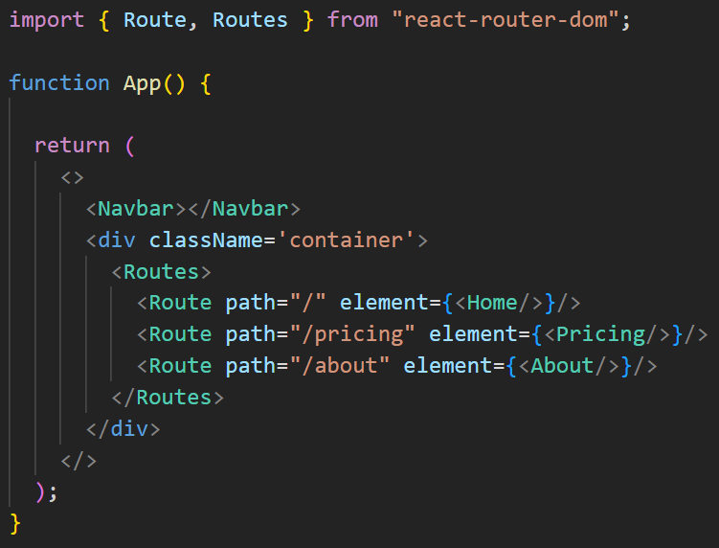
In Navbar.js, replace the anchor tags with links.
Old

New

Need to handle active links.

Import hooks in Navbar.js.
Look for matching route.

